

SONAR

BASED

PLOTTING

SYSTEM

TECHNICAL PROJECT REPORT

TITLE OF INVENTION/PROJECT: SONAR BASED PLOTTING SYSTEM

TEAM MEMBERS/INVENTORS:

S.No. | Name | Department | Designation | Mobile | E-Mail
1 | Alok Singh | CSE | Student | 7692912865 | alokmilenium@gmail.com
2 | Abhay Kohli | CSE | Student | 8198944808 | abhaykohli01@gmail.com
 |  |  |  | 8
3 | Sanyam Arora | CSE | Student | 9917576671 | sanyam99175@gmail.com
4 | Tanishq | CSE | Student | 9878944027 | aggarwal.tanishq@gmail.com
 | Aggarwal
5 | Devansh | CSE | Student | 7206697220 | devanshphugat@gmail.com
 | Choudhary
6 | Khushal | ECE | Mentor | 9646030764 | khushal.thakur@cumail.in
 | Thakur
7 | Anshul | ECE | Mentor | 9478697475 | anshulsharma.ece@cumail.in
 | Sharma
8 | Kiran Jot | ECE | Mentor | 9463909689 | kiranjotsingh.ece@cumail.in
 | Singh
9 | Divneet Singh | ECE | Mentor | 9878422653 | divneet.ece@cumail.in
 | Kapoor

SECTION 1 (IPR RELATED)

BRIEF ABSTRACT (500 WORDS)

- Problem your project is solving

- Collision of ships or submarines with any obstacle can be avoided.
- Parking accidents can be avoided.

- How are you solving the problem

SONAR based plotting system is designed to solve the problem.
- Obstacle is detected using sensor.
- This system measures the distance from obstacle and therefore avoids parking accidents.
- It can be used to measure water depth.

- Additional modifications that can cater to improve the solution

- An alarm can be introduced in case an obstacle is detected.
EXISTING STATE OF THE ART AND DRAWBACKS IN THE EXISTING STATE OF ART
(Brief background of the existing knowledge)

 |  | Drawbacks in
S.No. | Existing state of art | existing state of art
 | https://create.arduino.cc/projecthub/MakerRobotics/arduino-radar-version-2-0-24371e?ref=tag&ref_id=radar&offset=2 | - Obstacle is detected within small range only or within small degree of rotation.
1- |  | - Shape and size of obstacle is not determined.

ADDITIONAL MODIFICATIONS THAT YOU CAN PROPOSE TO IMPROVE UPON DRAWBACKS
- Degree of rotation can be increased.
- Using artificial intelligence, shape & size can be determined.

ADVANTAGES IF EACH FEATURE IS INCORPORATED :

- Product will become more accurate and will be sold at good cost.
- It will be more user friendly since it uses artificial intelligence.

BLOCK DIAGRAM

(Functional diagram depicting the flow of information in your system. Do not define exact components. Only use generic terms. Must include modifications as well.)
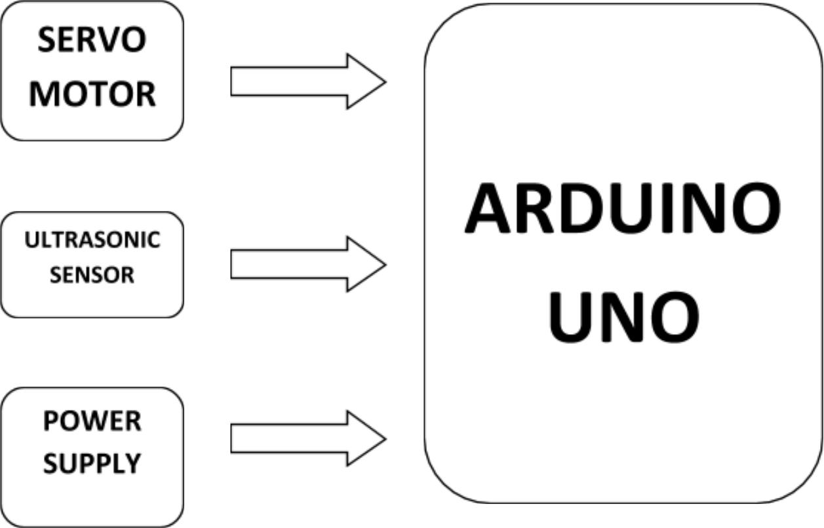

SECTION 2 (REAL PROJECT)

Materials:

- Ultrasonic sensor HC – SR04 (Rs. 150/-) Qty(1 piece)

- Arduino UNO (Rs. 400/-) Qty(1 piece)

- Servo Motor (Rs. 90/-) Qty(1 piece)

- Jumper Wires (Rs. 240/-) Qty(120 pieces)

- Printed Circuit Board (Rs. 100/-) Qty(2 pieces)

Circuit Diagram:

Steps of circuit completion:
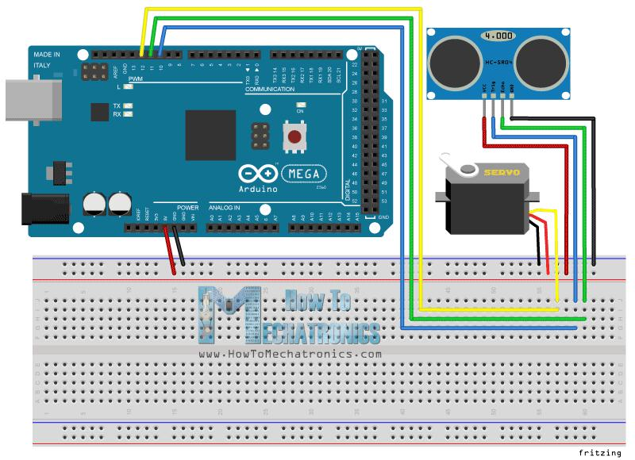
1. Fit ultrasonic sensor on the servo motor
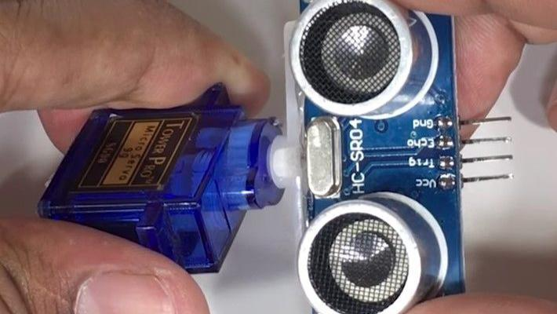

- Connect pin header on which 4 jumper wires are soldered and connect to sensor
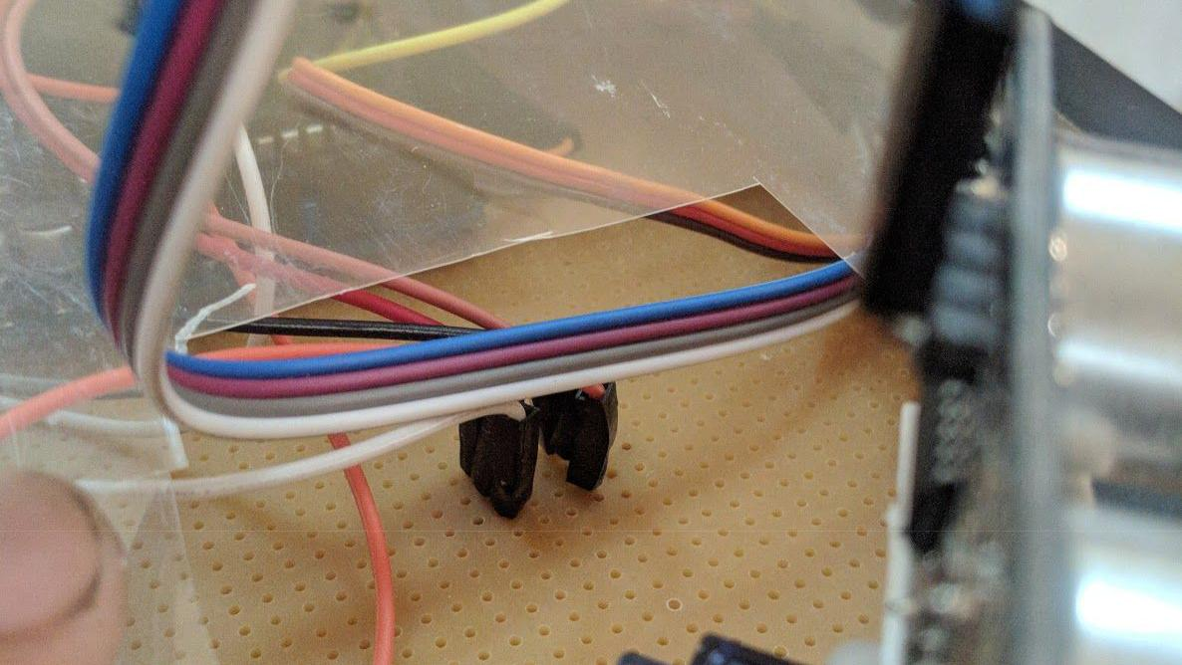
- Arrange the components and solder it on the printed circuit board
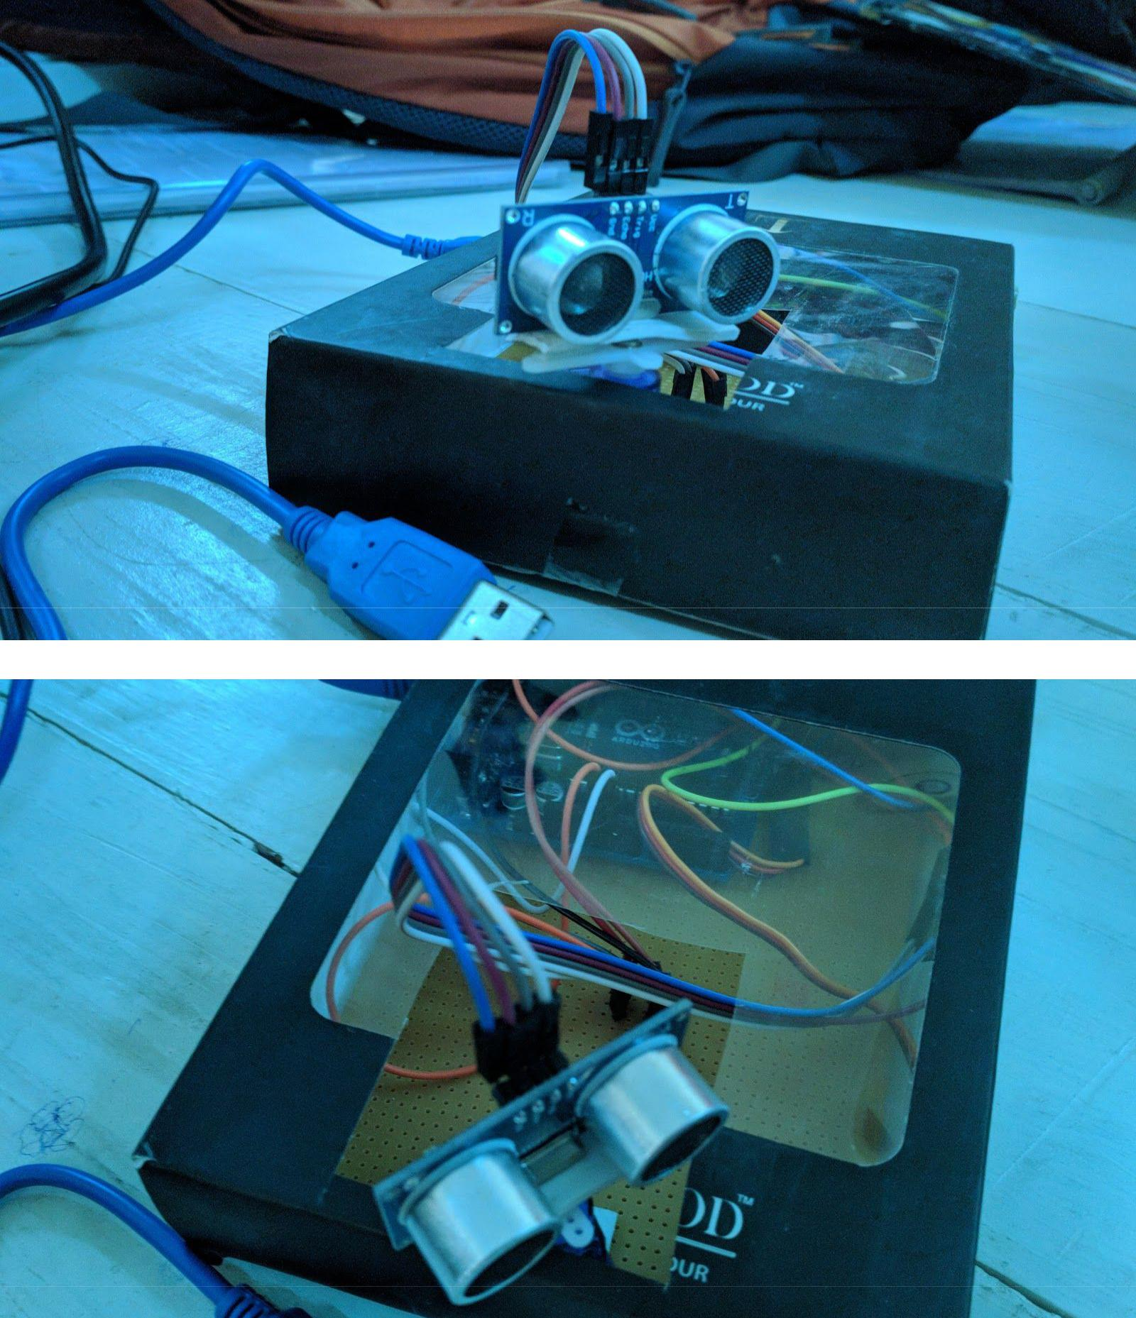

Program code:

github.com/sanyam99175/effective-happiness

